**CODE**

CREATE TABLE customers (

id NUMBER PRIMARY KEY,

name VARCHAR2(100),

age NUMBER,

balance NUMBER(12,2),

loan_interest_rate NUMBER(5,2),

isvip VARCHAR2(5) DEFAULT 'FALSE'

);

CREATE TABLE loans (

loan_id NUMBER PRIMARY KEY,

customer_id NUMBER,

due_date DATE,

FOREIGN KEY (customer_id) REFERENCES customers(id)

);

-- id, name, age, balance, loan_interest_rate, isvip

INSERT INTO customers VALUES (1, 'John Smith', 65, 15000, 8.5, 'FALSE');

INSERT INTO customers VALUES (2, 'Alice Brown', 45, 9000, 7.9, 'FALSE');

INSERT INTO customers VALUES (3, 'Mike Johnson', 70, 12000, 9.0, 'FALSE');

INSERT INTO customers VALUES (4, 'Emily Davis', 34, 10500, 8.2, 'FALSE');

INSERT INTO customers VALUES (5, 'David Wilson', 61, 8000, 9.1, 'FALSE');

-- loan_id, customer_id, due_date

INSERT INTO loans VALUES (101, 1, SYSDATE + 10);

INSERT INTO loans VALUES (102, 2, SYSDATE + 40);

INSERT INTO loans VALUES (103, 3, SYSDATE + 25);

INSERT INTO loans VALUES (104, 4, SYSDATE + 15);

INSERT INTO loans VALUES (105, 5, SYSDATE + 5);

COMMIT;

SELECT * FROM CUSTOMERS;

DECLARE

CURSOR cust_cursor IS

SELECT id, age, loan_interest_rate FROM customers;

BEGIN

FOR cust_rec IN cust_cursor LOOP

IF cust_rec.age > 60 THEN

UPDATE customers

SET loan_interest_rate = loan_interest_rate - 1

WHERE id = cust_rec.id;

END IF;

END LOOP;

COMMIT;

END;

SELECT * FROM CUSTOMERS;

**OUTPUT**

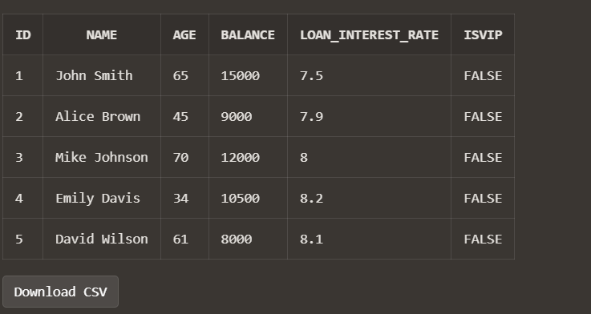

**CODE**

DECLARE

CURSOR cust_cursor IS

SELECT id, balance FROM customers;

BEGIN

FOR cust_rec IN cust_cursor LOOP

IF cust_rec.balance > 10000 THEN

UPDATE customers

SET isvip = 'TRUE'

WHERE id = cust_rec.id;

END IF;

END LOOP;

COMMIT;

END;

SELECT * FROM CUSTOMERS;

**OUTPUT**

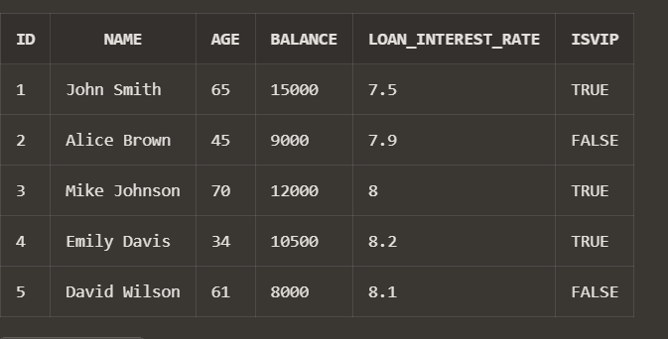

**CODE**

DECLARE

CURSOR loan_cursor IS

SELECT l.loan_id, l.customer_id, c.name, l.due_date

FROM loans l

JOIN customers c ON l.customer_id = c.id

WHERE l.due_date <= SYSDATE + 30;

BEGIN

FOR loan_rec IN loan_cursor LOOP

DBMS_OUTPUT.PUT_LINE('Reminder: Dear ' || loan_rec.name ||

', your loan (ID: ' || loan_rec.loan_id ||

') is due on ' || TO_CHAR(loan_rec.due_date, 'DD-MON-YYYY'));

END LOOP;

END;

**OUTPUT**

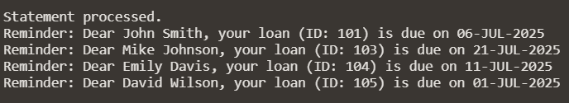

Link : <https://livesql.oracle.com/ords/livesql/s/dmmehe8aufrtftng7fylkx5kh>